**UK Road Safety: Traffic Accidents Report**

**Context**

The dataset used to prepare this report comes from the Open Data website of the UK government, where they have been published by the Department of Transport. It contains significant information about traffic accidents in the UK; mainly, geographical locations of accidents, weather conditions, type of vehicles, number of casualties, age bands, vehicle maneuvers and other data related to traffic accidents.

The dataset comprises of two csv files:

**AccidentInformation.csv**: every line in the file represents a unique traffic accident, featuring various properties related to the accident as columns.

**Vehicle_Information.csv**: every line in the file represents the involvement of a unique vehicle in a unique traffic accident, featuring various vehicle and passenger properties as columns.

**Data limitations**

Unfortunately, there are data limitations related to total volume of vehicles on the roads at any given time by certain conditions. This limitation added extra uncertainty when drawing conclusions on yearly traffic accidents and severity counts, the influence of weather conditions on accidents and analysing day time / weekly number of traffic accidents.

**Analysis and Findings:**

UK Traffic Accidents over time:

The data shows that there is an increase in number of traffic accidents with the period of 2010 and 2016. Evidently, this is proportional to the increase of traffic volume over time. The total number of accidents in 2010 were 106,701, however in 2016 it is as high as 117,474. Clearly, the number of fatal accidents also increased over time from 1193 in 2010 to 1480 in 2016. The same increasing trend is observed in number of serious accidents from 13,195 to 18,177 in six years’ time. Although during 2012 and 2013 the number of accidents seem to have dropped, however the positive trend is reversed in 2014. The volume of traffic has increased over the years from 2010 to 2016 although this has been a minimal increase from 305.8 vehicles in 2010 to 338.2 vehicles in 2016. This increase in traffic volume over the years could be a factor contributing to the increase of accidents from 2014 to 2016 as the volume of traffic increased by 16% between these two years.

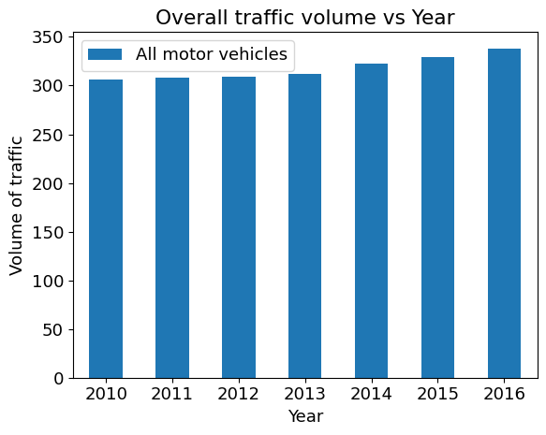

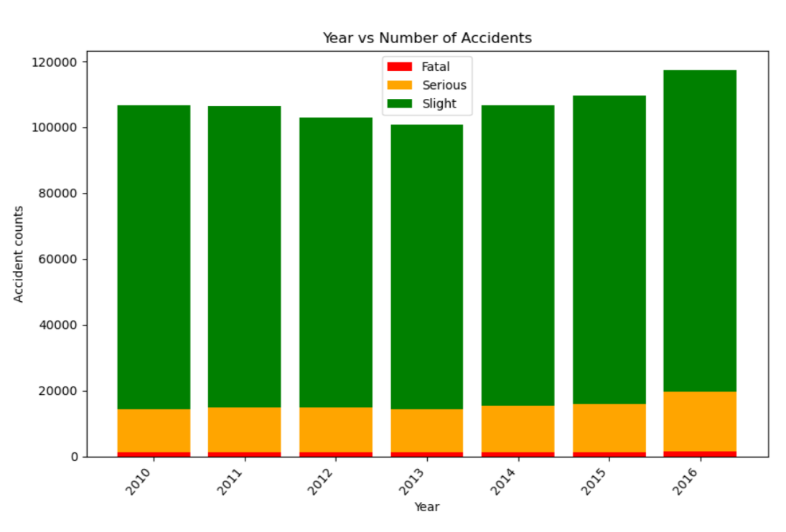

UK Traffic Accidents and Severity:

The dataset categorizes the accident severity levels by slight, serious, and fatal. According to the data, majority of traffic accidents that occurred between 2010 and 2016 are slight (86%), while around 12% of accidents are serious and 1% is fatal.

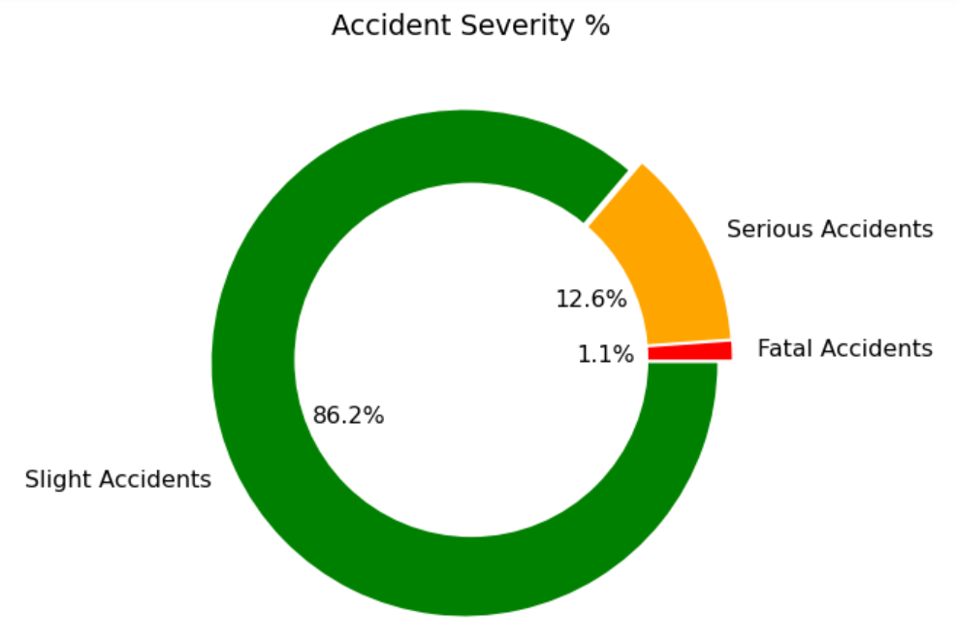

Location as a factor in UK Traffic Accidents

To identify the locations of main traffic accidents, a google maps plot was created with a heatmap layer based on just the locations. The plot indicates that from 2010-2016 almost the entirety of Birmingham has had accidents and indicates a greater number of accidents happen in the areas closer to the city center.

This is likely due to the traffic concentration increasing around the city center and from other plots it was determined that rush hour traffic increases the number of accidents. As the city center is the central hub for business in Birmingham this means the traffic concentration around the city center would be very high during commuting hours.

The accident locations heatmap was repeated, however this time the Accident Severities were added as weights. Again, the map seems to indicate more serious and fatal accidents were concentrated in the city center. However, this could be just a repeat of the concentrations of accidents further enhanced by the severity.

The following plots show all the accidents in the filtered data set (years from 2010-2016) and therefore covers most of the United Kingdom. It is evident that most of the accidents are concentrated in Large Cities and Towns (Urban areas) where there is a large population and therefore concentration of traffic, which would have led to a greater number of accidents.

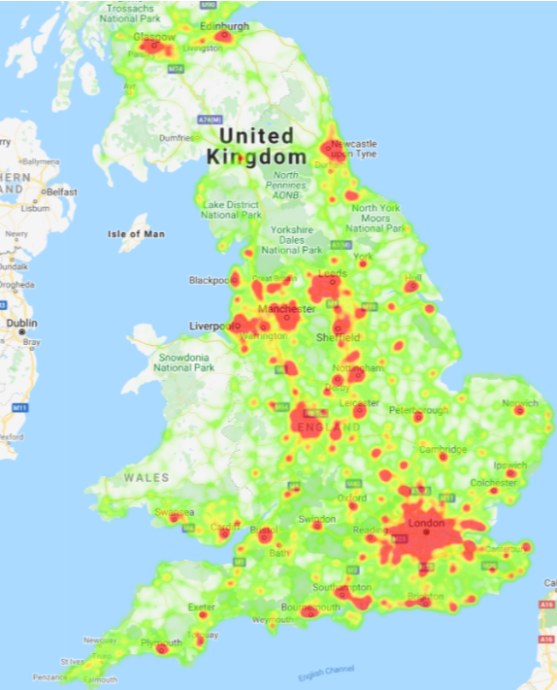

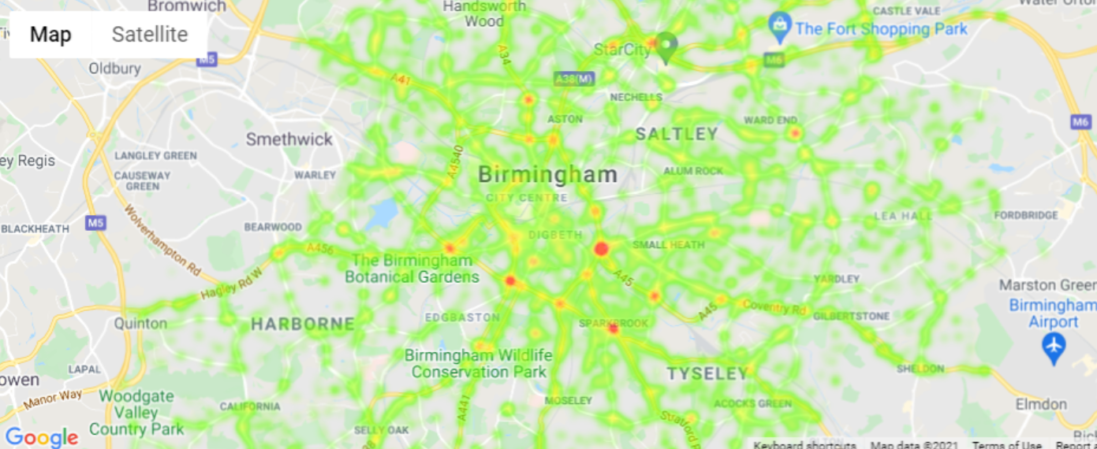

Day and Time of UK Road Traffic Accidents

During the period from 2010 to 2016 within the working week the number of accidents gradually increases from Monday with a significant increase on a Friday. The number reduces on Saturday and again on Sunday. The severity of accidents remains similar on each day. This may simply be related to the volume of traffic on the roads.

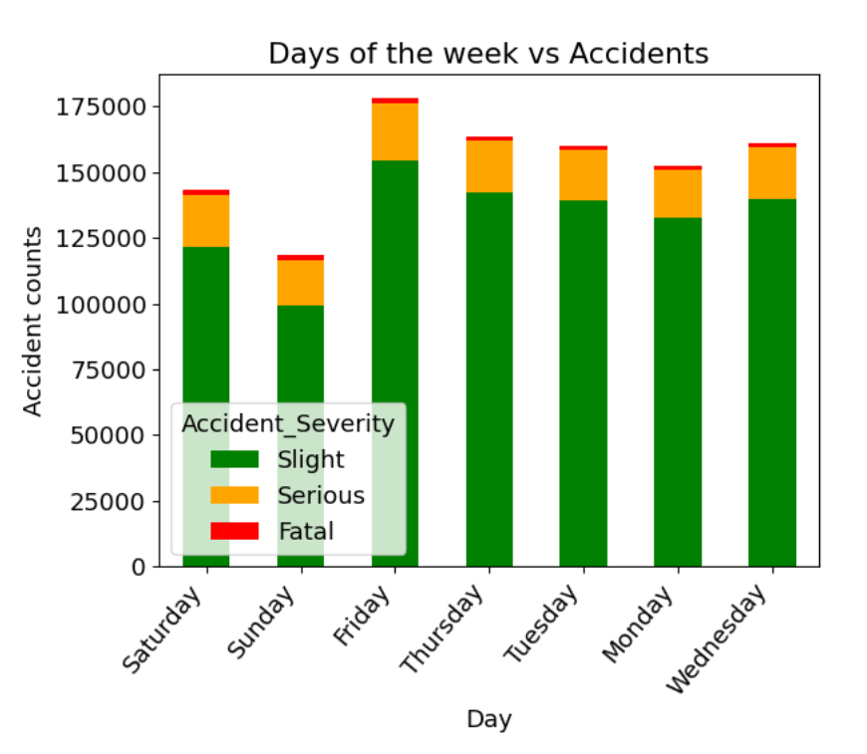

Using our dataset from 2010-2016, we have plotted a line graph to compare number of casualties against the hour of the day to determine what time of the day carries the most risk to travel and whether it is weekdays or the weekend. From the above plot, we established that the weekdays Monday to Thursday follow a similar trend where there is a spike in number of casualties at 8am and again at 5pm. The increase of accidents at these times could be due to an increase of road traffic at these times, being that more people are often commuting to and from work. Friday also closely follows this trend however, seems to have a greater number of casualties from 10am until 4pm where it reaches a peak. This is an interesting observation for Friday, which we can assume that is a result of Friday being at the end of the working week and people may be tired and rushing home to start their weekend. The number of casualties vs the hour of day follows an entirely different pattern on Saturday and Sunday in comparison with weekdays. This is expected as not many people will be working on the weekend, which may mean a reduced number of vehicles on the road. The greatest number of casualties on the weekend are between the hours of 11am and 1pm, as opposed to 8am and 5pm on weekdays. Sunday has the least number of casualties at any given time, and its peak casualties is at 1pm where there is a total of 15266 casualties. In comparison, Tuesday has the greatest peak out of all the days with a total of 24622 at 5pm, which is 9,356 more casualties than Sunday’s peak at 1pm.

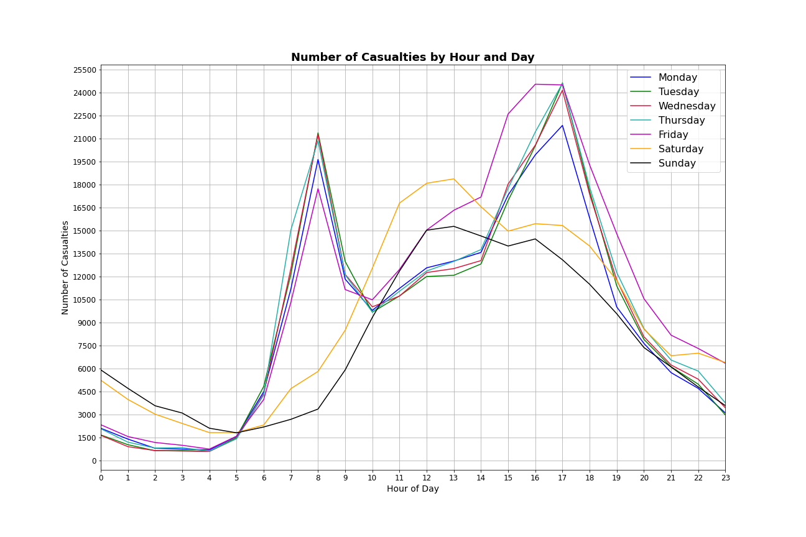

Here we analysed the number of accidents occurring at different hours in the day and the number of fatal accidents occurring through the day. By plotting a line graph, we were able to see how the number of accidents fluctuate at different hours and whether the number of fatal accidents is related to the peak number of accidents. From the graphs we can suggest that the greatest number of fatal accidents take place at 5pm, and the greatest number of total accidents also occur at 5pm. This is presumably due to the after-work commute, and where people may be tired and, in a rush, to get back home. There is also a peak in number of accidents at 8am where people may be commuting to work or dropping children off to school, so there will be more vehicles on the road, leading to an increased risk of accidents occurring. The least number of accidents including fatal accidents occur at 4am, where the least number of vehicles may be on the road. Comparing the number of accidents graph with the previous figure showing number of casualties vs the hour of day, we can see a very similar pattern between the two especially for the weekdays from Monday to Thursday.

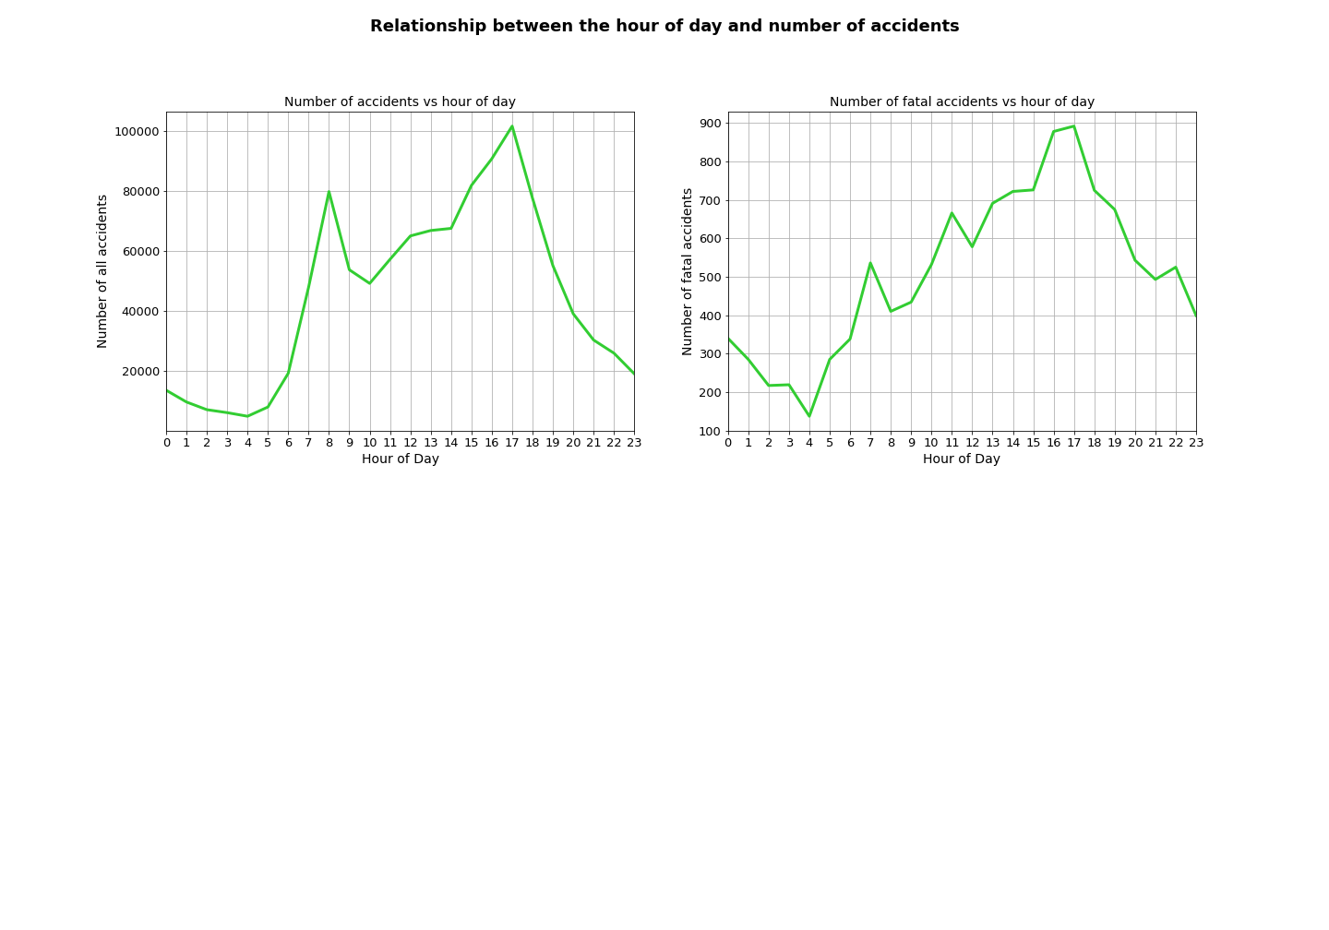

**Speed Limit as a factor in UK Road Accidents**

From our data set we analysed the involvement of speed limit in UK road accidents from 2010-2016, to determine a causation of whether higher speed limits contribute to more road accidents in the UK. Subsequently, we have plotted a bar graph of the results and we can conclude that most accidents occurred in regions where there was a 30mph speed limit, and these made up 46.69% of total accidents recorded. The second greatest number of accidents occurred in 60mph zones; 21.93% of total accidents. These findings may be a result of the 30mph speed limit applying to all single and dual carriageways with street lights, which is a large portion of all roads within the UK.

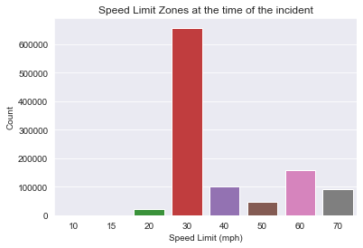

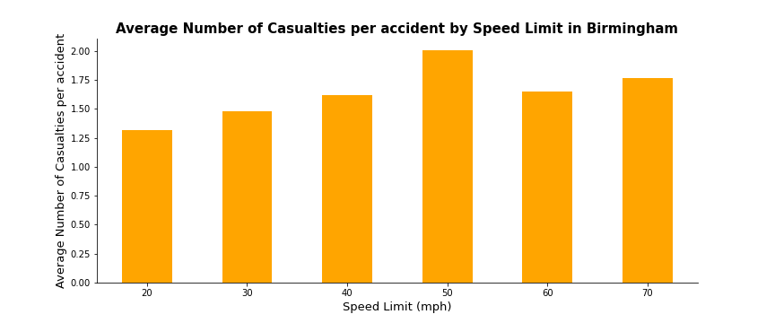

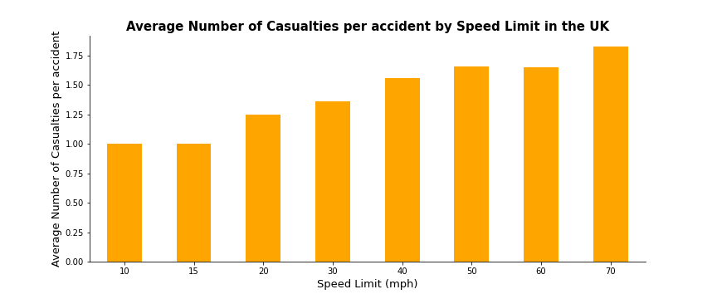

We have also explored mean number of casualties per accident in various speed limits. From the bar plots we can infer that although most occur in 30mph speed limits, that the greatest average number of casualties result from accidents in 70mph zones, where the average casualties are 1.82 in 70mph zones and 1.35 in 30mph zones. The plot also suggests that the average number of casualties increase as the speed limit increases.

We have also explored the average number of casualties per accident for Birmingham and from this can observe that the greatest number of average casualties are resulting from 50mph (2), and the least resulting from accidents in 20mph zones (1.31). From our findings we can propose that it is safer to travel at

lower speed limits such as 10mph and 20mph as this greatly reduces the average number of casualties

and the overall number of accidents.

Age and gender as a factor in UK road Traffic Accidents

During the period from 2010 to 2016 men were named as driver in just over 60% of accidents whilst women were named as driver in 36%. It is not straightforward to draw a firm conclusion without the knowledge of how traffic volume is split between gender. Nevertheless, according to available data, it is reasonable to suggest that women are safer drivers than men.

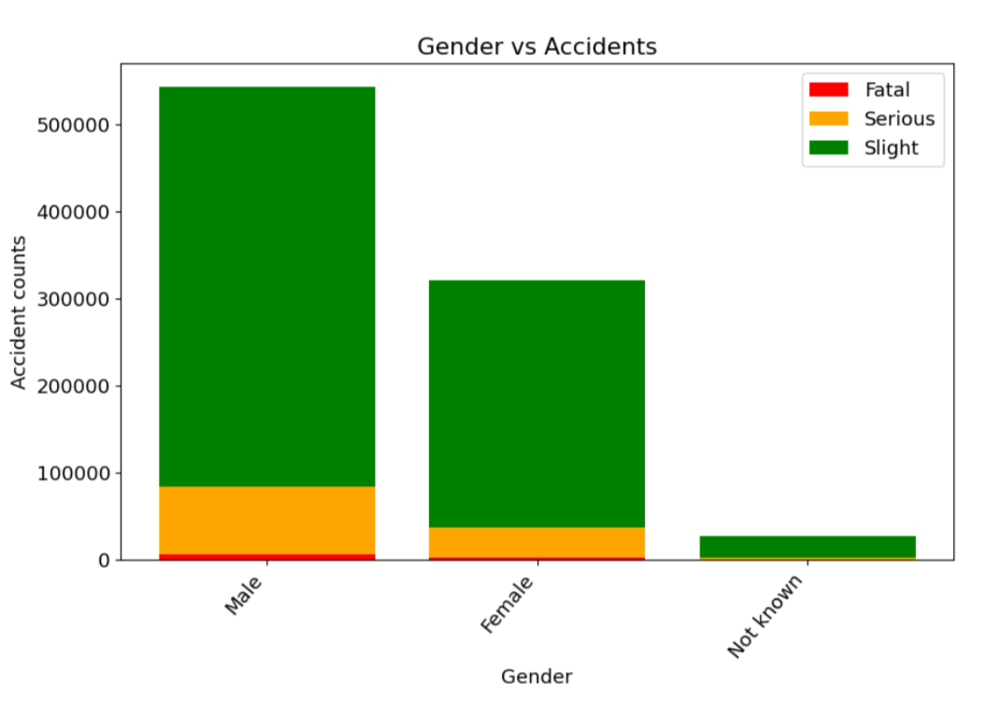

During the period from 2010 to 2016 the age group involved in most accidents was 25–35-year-olds. Unfortunately, there is not enough data to show what proportion of driving is done by that age group compared to others, so this limits the certainty of this conclusion. The severity of accidents is similar for most age groups, although it does appear that in the over 75 age group, there is a higher proportion of ‘Slight’ accidents.

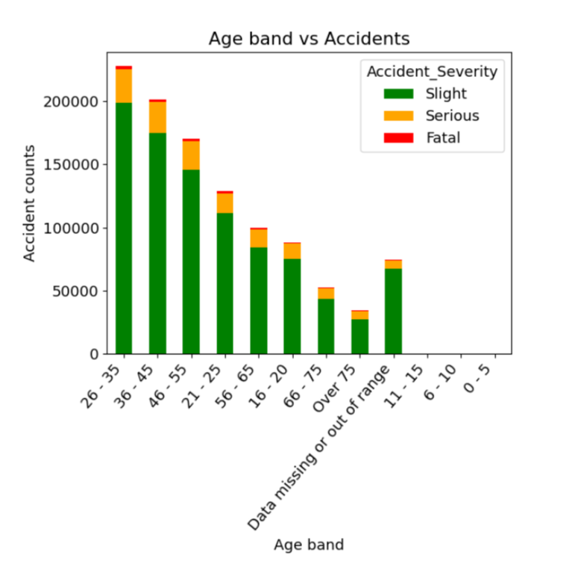

Vehicle manoeuvres and location as a factor of UK Traffic Accidents

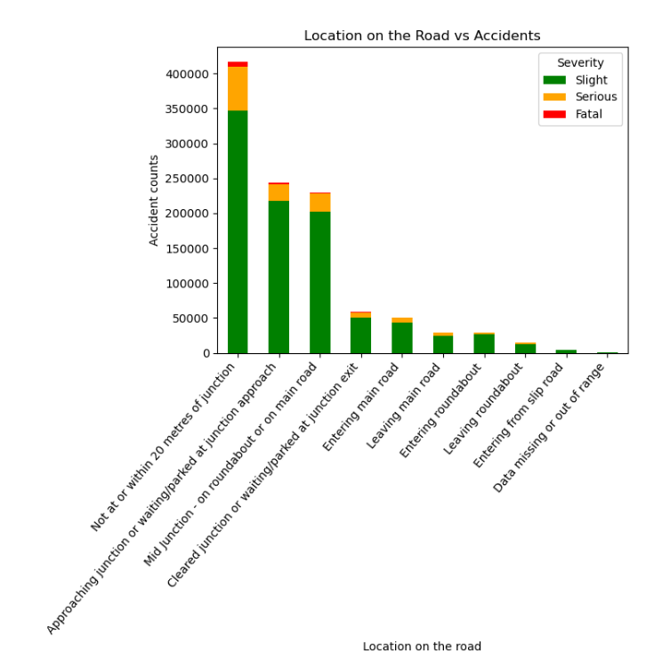

During the period from 2010 to 2016 there were significantly more accidents where there is no junction within 20 meters. These accidents are more serious and unfortunately more are fatal. This may be due to the higher speed that vehicles travel on the ‘open road’. It is also significant that many accidents happen when approaching or navigating a junction or roundabout whereas ‘slip road’s’ appear to be safer.

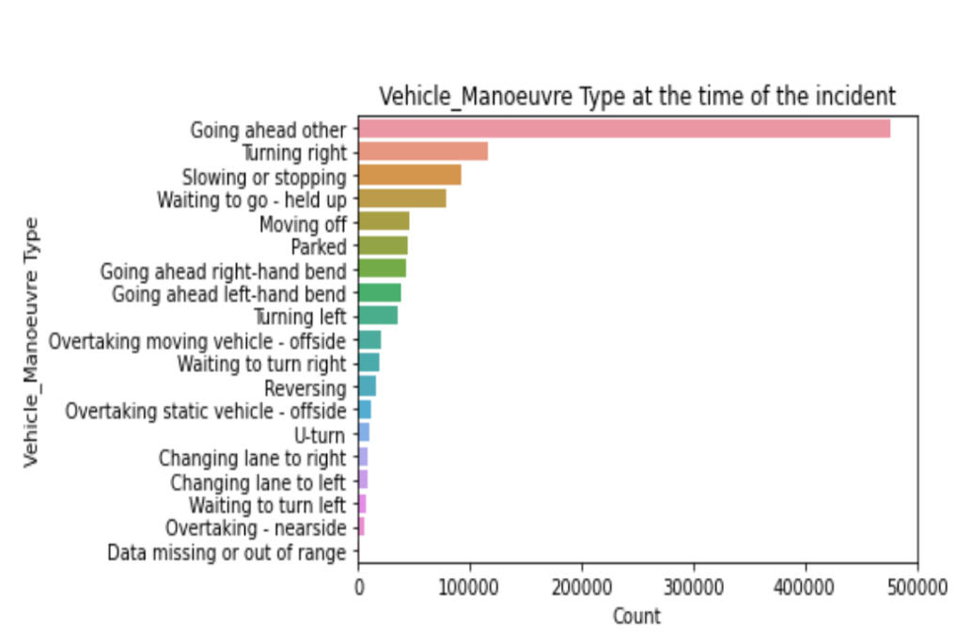

This plot shows that most accidents occurred when vehicles were "going ahead", compared to any other manoeuvre documented. This suggests that the cars were in their lanes or perhaps on single carriageways, and this may have led to an accident involving the car in front or the car behind. A causation of this may be using mobile phones whilst driving that significantly lowers concentration and not braking in time. Turning right is the second greatest manoeuvre involved in accidents, which may be down to several reasons and related to other vehicle manoeuvres such as overtaking. There is a lot less accidents for other vehicle manoeuvres such as reversing and moving off in comparison to going ahead, which may be because people are often more alert and attentive to the road when reversing or moving off, than they are when driving down a straight road and having lower concentration.

**Weather conditions vs accidents**

In this section we have looked into the accidents dataset to investigate if there is any correlation between accident occurrences and weather conditions. The findings showed that 69% of accidents occurred on dry road conditions with no rain or snow. Surprisingly, 80% of accidents happened in fine weather with no high wind speed, rain or snow, whilst only around 12% of accidents happened in rainy weather. The dataset also shows that road conditions were reported to be damp or wet when 27% of accidents occurred, which would indicate that accidents occurred not long after rain or snow fall.

Accidents mainly occurred in good weather conditions. This could be related to the fact that drivers are more attentive when driving in bad weather conditions and tend to be more relaxed in fine weather conditions. Around 27% of accidents are reported to have happened on wet or damp roads but during no rain or snow. This could mean the roads were still slippery and could influence the accident occurrences when drivers were making various maneuvers. There are no months with especially higher number of accident occurrences. The number of accidents is evenly distributed throughout the year.

